What’s Included
Your Power Station Afternoon Tea includes bottomless teas and a generous selection of savoury and sweet treats.
Savoury Selection
- Tomato, mozzarella and basil canapé (vegetarian)
- Avocado and feta canapé (vegetarian)
- Mini quiche with sun-dried tomatoes and Cheddar (vegetarian)
Scones
Enjoy three freshly baked scones:
- Plain scone
- Red Velvet scone
- Cheese scone
Served with:
- Jam
- Clotted cream
- Butter
Sweet Treats
- Electric lemon tart
- Flower fruit custard tart
- DIY Cats & Dogs cupcakes (Vanilla or Chocolate - 1 per person)
- Chocolate chip brick brownie finger
- White chocolate and pistachio blondie finger
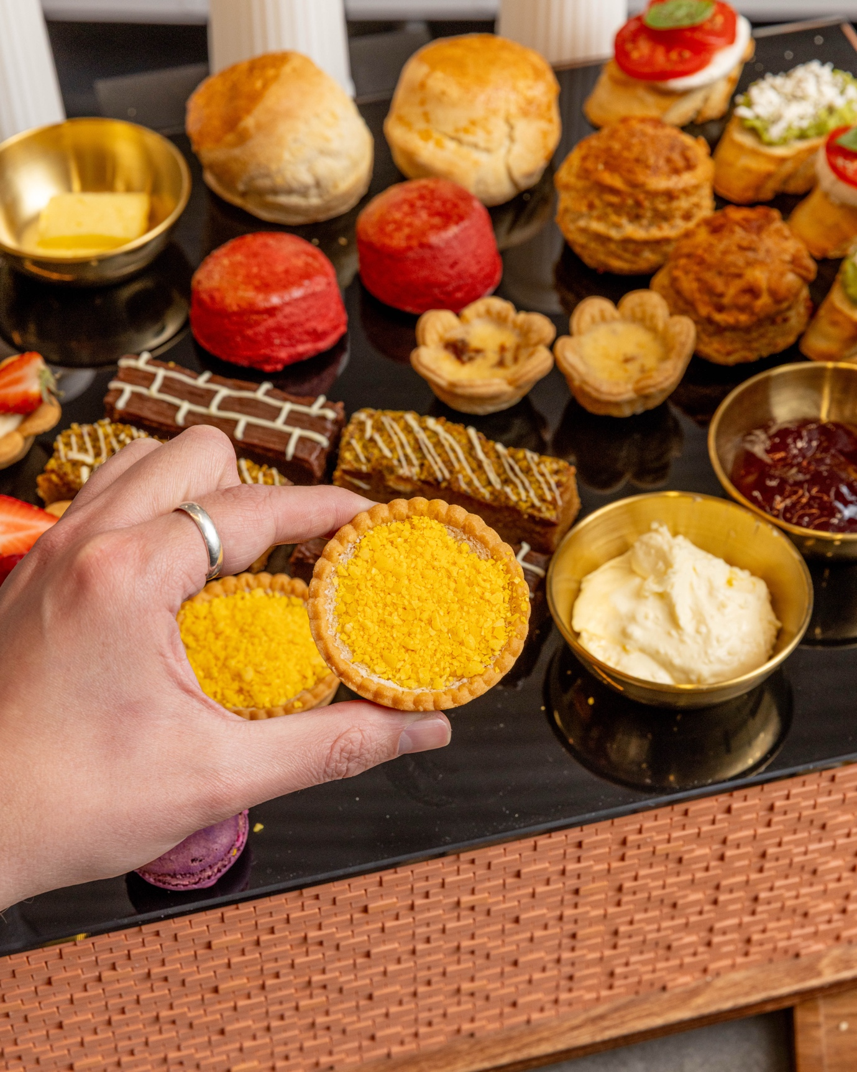
Bottomless Teas
Relax and enjoy bottomless teas throughout your experience. Our teas are sourced from award-winning Novus Tea. Our tea menu includes:
- English Breakfast
- Sapphire Earl Grey
- Decaff Ceylon
- Persian Pomegranate
- Citrus Chamomile
- Dragonwell Green
- Egyptian Mint
You are welcome to mix and match and try all of them.

